Project Description

Project title
English Learning Management System for NP Language Center

Customer description
NP Language Center is a private English language training center providing English education services for learners of different ages and proficiency levels. The center offers general English courses, IELTS preparation programs, and skill-based classes focusing on listening, speaking, reading, and writing.
In terms of scale, NP Language Center currently operates five training facilities (branches) to serve learners in different locations. The center employs approximately 50-60 English teachers, including both full-time and part-time instructors. The number of active students is around 500-600 learners, distributed across different classes and proficiency levels across all five branches. This scale of operation requires effective coordination in class scheduling, academic management, and student support to ensure consistency in teaching quality.
The primary goal of NP Language Center is to provide a modern learning environment that enhances students’ learning experience while ensuring strict management of learning outcomes and educational quality. The center aims to improve teaching effectiveness, monitor student progress more closely, and maintain consistent academic standards across all branches through the application of information technology in management and learning activities.
The organization’s structure is as the following diagram:
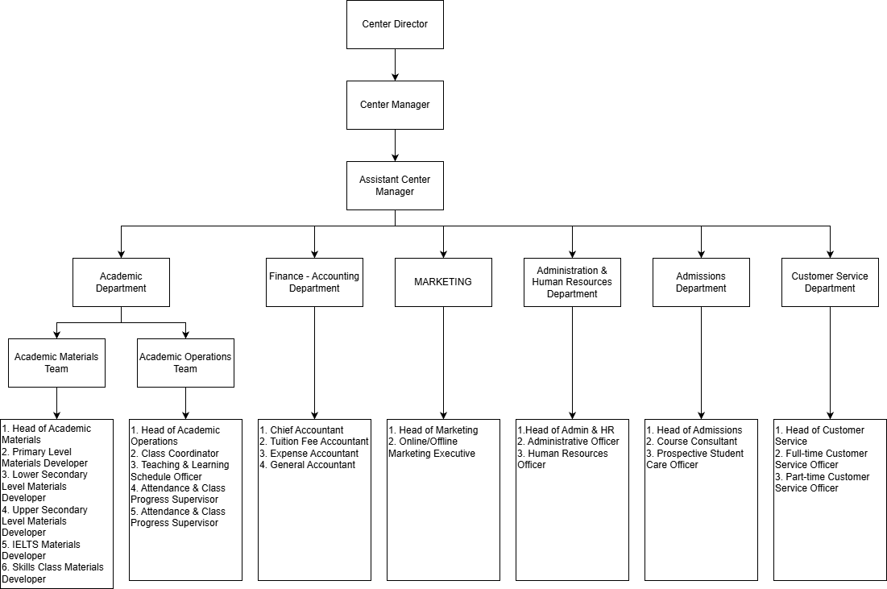

Business Process
NP Language Center operates through several functional units that collaborate to deliver educational services across all five branches. The main departments include Admissions, Academic, Teaching Staff, Finance, Customer Service, and administrative support. The Admissions Department is responsible for student consultation and enrollment. The Academic Department manages curricula, class scheduling, and academic quality control. Teaching Staff conduct lessons, assign learning tasks, and evaluate student performance. The Finance Department handles tuition collection and financial records, while the Customer Service Department supports students, manages communication, and follows up on attendance and learning issues.
Currently, the center manages its core business processes using Zalo and Excel, without a centralized information system. Communication between staff, teachers, and students is mainly conducted through Zalo groups, while operational data is stored and updated manually in Excel spreadsheets.
For the student attendance management process, class schedules are prepared by the Academic Department and shared with teachers via Zalo. During each class session, teachers manually track student attendance using paper notes or personal records. After the class, attendance information is sent to Academic or Customer Service staff through Zalo messages. This data is then manually compiled and stored in Excel files. Customer Service staff review attendance records in Excel and contact absent students individually through Zalo or phone calls to follow up.
For the learning management process, teachers distribute learning materials, homework assignments, and class announcements through Zalo groups. Students submit their assignments by sending images or files via chat. Teachers review the submissions manually and send learning results to the Academic Department through Zalo. Academic staff then update student progress records in Excel. Customer Service staff use these Excel records to monitor learning performance and respond to student inquiries.
This manual and fragmented approach leads to several operational challenges, including information loss in chat messages, duplicated data entry, limited tracking of student progress, delayed feedback, and difficulty in maintaining consistent academic quality across branches. These limitations provide a strong justification for proposing an integrated information system in later sections of this project.

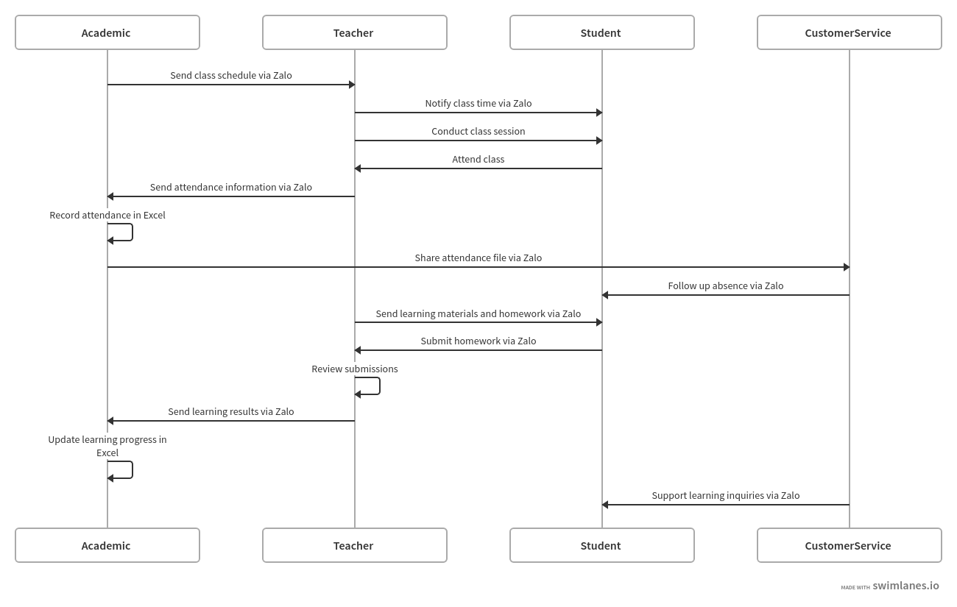

Project summary
The project aims to create a mobile app that supports English learning and includes features for managing academic tasks like class schedules, attendance tracking, homework assignments, and progress evaluation. The system is designed to improve learning efficiency, lower administrative workload, and enhance communication among students and teachers. Expected results include greater student engagement, better tracking of performance, and more effective class management. This project is important because it brings social and economic benefits. It helps schools use resources more wisely, cut down on paperwork, and improve the quality of services. For learners, the system provides a structured, interactive, and convenient way to learn English.

Significance and innovation
This project aims to tackle practical challenges faced by English training centers. Currently, student management and attendance tracking mainly rely on Zalo and Excel spreadsheets. This manual method is time-consuming, prone to data entry mistakes, and does not offer real-time updates. As a result, teachers and administrators struggle to effectively monitor learning progress. The innovation of the proposed system comes from replacing scattered spreadsheet management with a unified mobile application. This app combines English learning content delivery with academic management tasks. This system provides complete class management, attendance tracking, homework assignments, and progress monitoring all in one platform.
The system features a mobile-based learning management system (LMS) with cloud data storage, real-time attendance and progress monitoring, and role-based access for students and teachers. These innovations greatly improve operational efficiency, reduce mistakes, and boost overall learning effectiveness.

Approach
Describe the methodology / programming language / framework/ technologies… to be used?

Expected outcomes
The implementation of the mobile-based English Learning Management and Support System is expected to bring transformative changes to the operations of NP Language Center:
- Operational and Administrative Efficiency: The system will completely replace fragmented management methods currently relying on Excel spreadsheets and messaging applications. The primary outcome is the establishment of a centralized database that minimizes data entry errors and enables departments, such as Finance and Academic, to access real-time information. Digitizing processes like attendance tracking, class scheduling, and tuition management will optimize resources and significantly reduce administrative paperwork.
- Teaching and Academic Quality: Teachers will be able to perform academic tasks, such as assigning homework, recording attendance, and evaluating student progress, directly through the mobile application instead of manual record-keeping. This not only ensures closer monitoring of each student's learning path but also enhances transparency in performance assessment.
- Learner Experience and Engagement: The application provides students with an interactive and flexible learning environment, allowing them to access materials and complete quizzes anytime and anywhere. Instant connectivity through app notifications will foster greater student proactivity and improve the overall interaction between learners and the center.
Likely Impact: This project is anticipated to enhance economic efficiency by streamlining operations while delivering social value through improved educational service quality. It establishes a modern foundation for the center's sustainable development in the digital age.

Description of personnel
8.1. Stakeholders Summary
Stakeholder | Role | Responsibilities | Contributions
NP Language Center (The Customer) | System Owner & End-user | Provides business requirements, feedback on prototypes, and validates system functionality. | Supplies domain expertise, operational data (Excel files), and final approval for deployment.
Project Development Team | System Developers | Analyzing, designing, and building the mobile application. | Provides technical solutions, software architecture, and final product delivery.
Students & Teachers | Primary Users | Using the app for learning, teaching, and administrative tasks. | Provide user experience feedback to improve the app's usability and effectiveness.

8.2. Detailed Team Member Profiles
The development team consists of five members, with specialized roles and responsibilities:
- Đỗ Thanh Hải – Project Manager (PM)
  - Role: Lead coordinator and manager of the project lifecycle.
  - Responsibilities: Project planning, timeline management, resource allocation, and risk mitigation.
  - Details: Ensures the project adheres to the ISD course requirements and maintains communication between team members.
- Đào Thanh Hiền – Business Analyst (BA)
  - Role: Requirement analyst and process modeler.
  - Responsibilities: Eliciting requirements from NP Center, modeling business processes (consulting, enrollment, tuition), and defining system specifications.
  - Details: Focuses on translating the center's manual Excel/Zalo workflows into digital logic.
- Phạm Văn Hòa – Lead Developer (Backend & Architecture)
  - Role: Technical architect.
  - Responsibilities: Designing the database schema, cloud integration, and backend API logic.
  - Details: Responsible for the technical foundation of the organizational structure and role-based access control.
- Đinh Thị Khuê – Developer (Core Features)
  - Role: Feature implementation developer.
  - Responsibilities: Coding core LMS modules, including attendance tracking, homework assignment notifications, and progress monitoring.
  - Details: Focuses on digitizing class management and real-time performance tracking features.
- Nguyễn Minh Nguyệt – Developer (UI/UX & Outcome Metrics)
  - Role: Interface designer and developer.
  - Responsibilities: Designing the mobile user interface (UI), optimizing user experience (UX), and defining project evaluation metrics.
  - Details: Ensures the app is intuitive for both academic staff and students.
9. Feasibility study

